**Sree Narayana College for Women Kollam**

**Workshops/Seminars on Research Methodology, Intellectual Property Rights (IPR) and Entrepreneurship**

**2021-2022**

1. **Release of Newsletter ‘Thanmathra’ on 25th March 2022**

The department newsletter ‘Thanmathra’ Vol. 16, has been released by Prof. Nisha J Tharayil, Principal, SN college for Women, Kollam on 25th March 2022. Dr. Chithra P G, Head of the Department has delivered the welcome speech. 55 students and 12 teachers have attended the programme. Student editors have shared their experience during the production of this newsletter. Dr. Poornima Vijayan P, Assistant Professor, Sree Narayana College for Women, Kollam has delivered the vote of thanks.

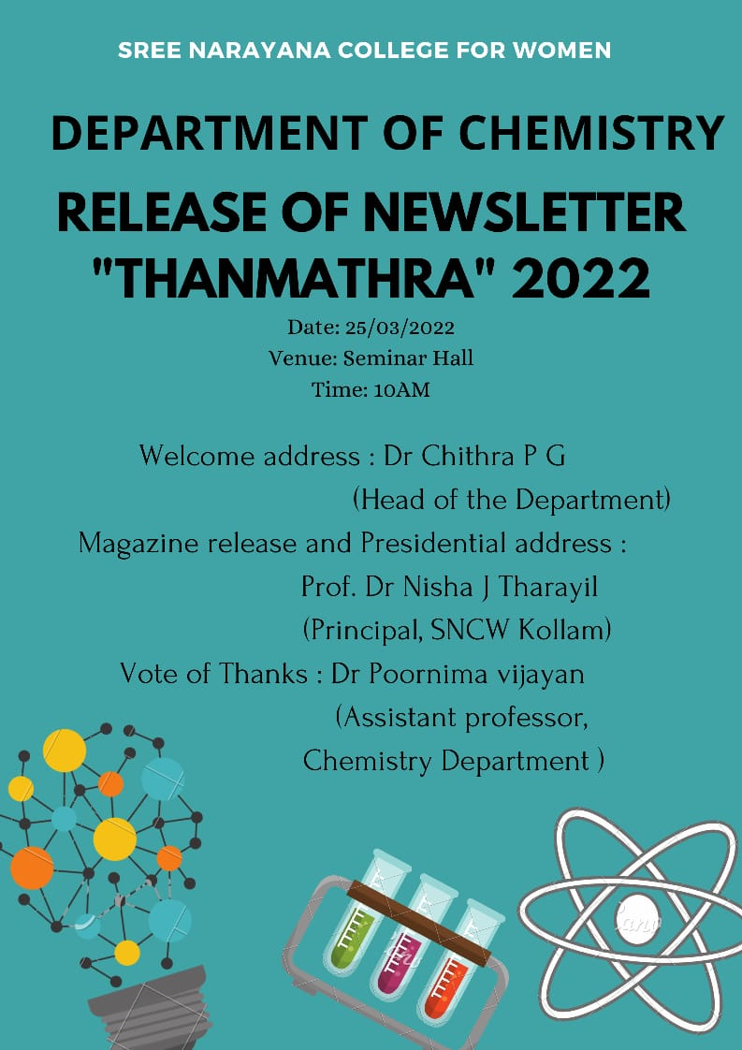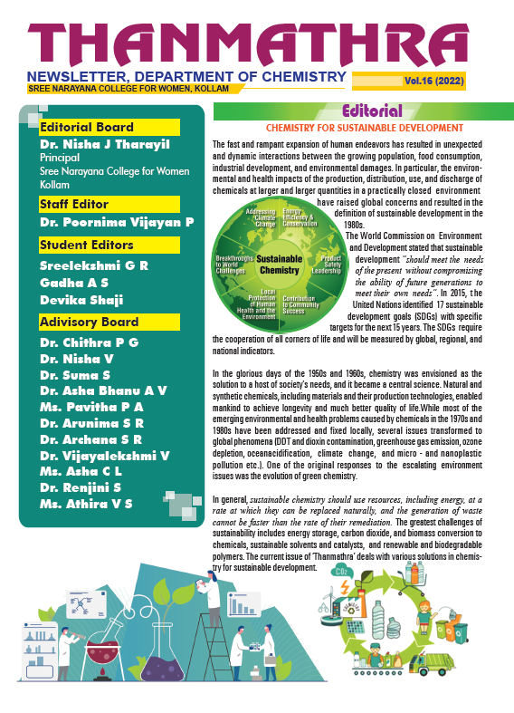

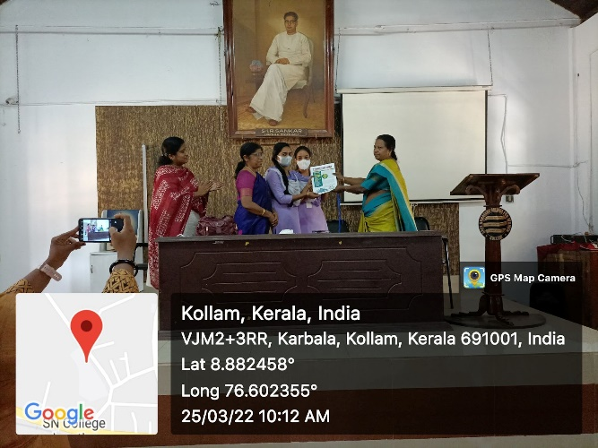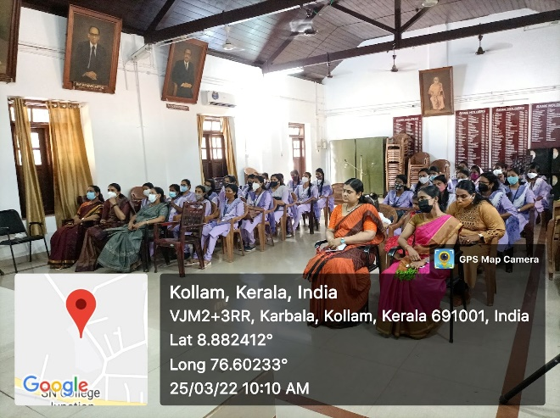

1. **Hands-on training on Impedance Analyser**

A hands-on training on Impedance analyser has been given by Mr. Karthik A S, Field & Applications Engineer, Innovative Instruments Inc., on 24-03-2022. The session was very useful to the students and faculties to explore Impedance analyser for the characterisation of various electric conductive materials. 10 students from department of physics and chemistry have been attended the training.

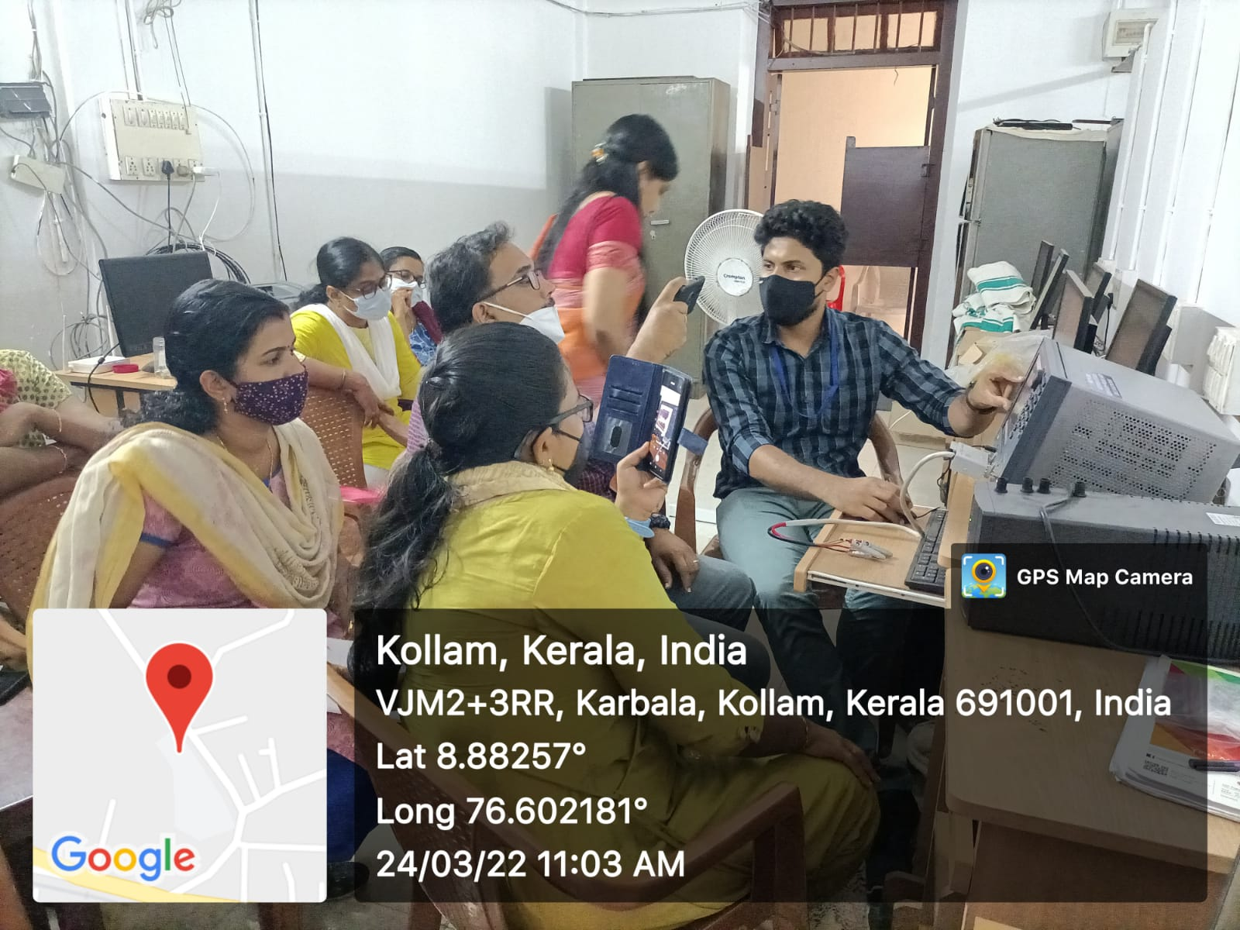

1. **Thrift Exhibito**

On 15/03/2022 as part of “**Earn While You Learn project**”, Entrepreneurship Development Club and Department of Commerce jointly organised an exhibition cum sale named **Thrift Exhibito** at College auditorium. Dr. Sajitha, Assistant Professor, Department of commerce, coordinated the exhibition. It was a golden opportunity to our students for exhibiting their talents in making of craft items, food items and cleaning products like dishwash gel, bathing soap, room freshner, cleaning lotion, detergent etc.

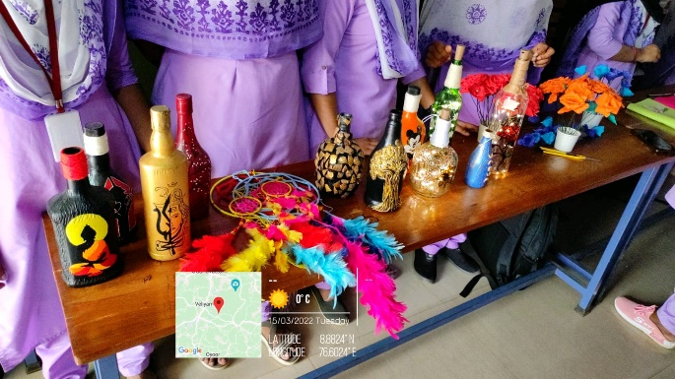 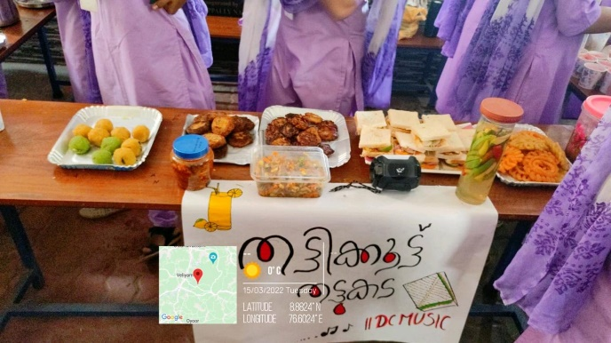

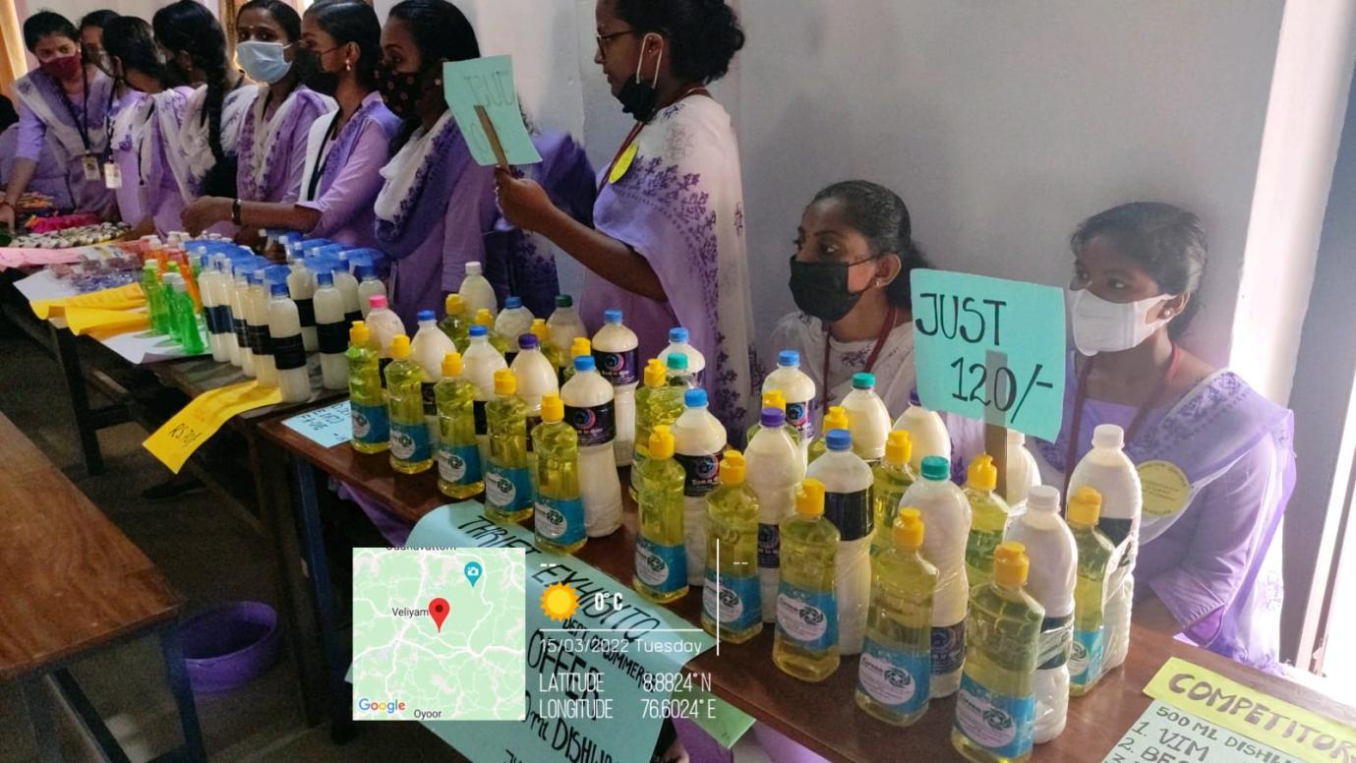

1. **Training Class on Making Room Spray**

On 10/03/2022, a skill development programme on making room spray was organised by Entrepreneurship Development Club. Smt. Saraswathy Radhakrishnan was the trainer. 75 students were participated in the training.

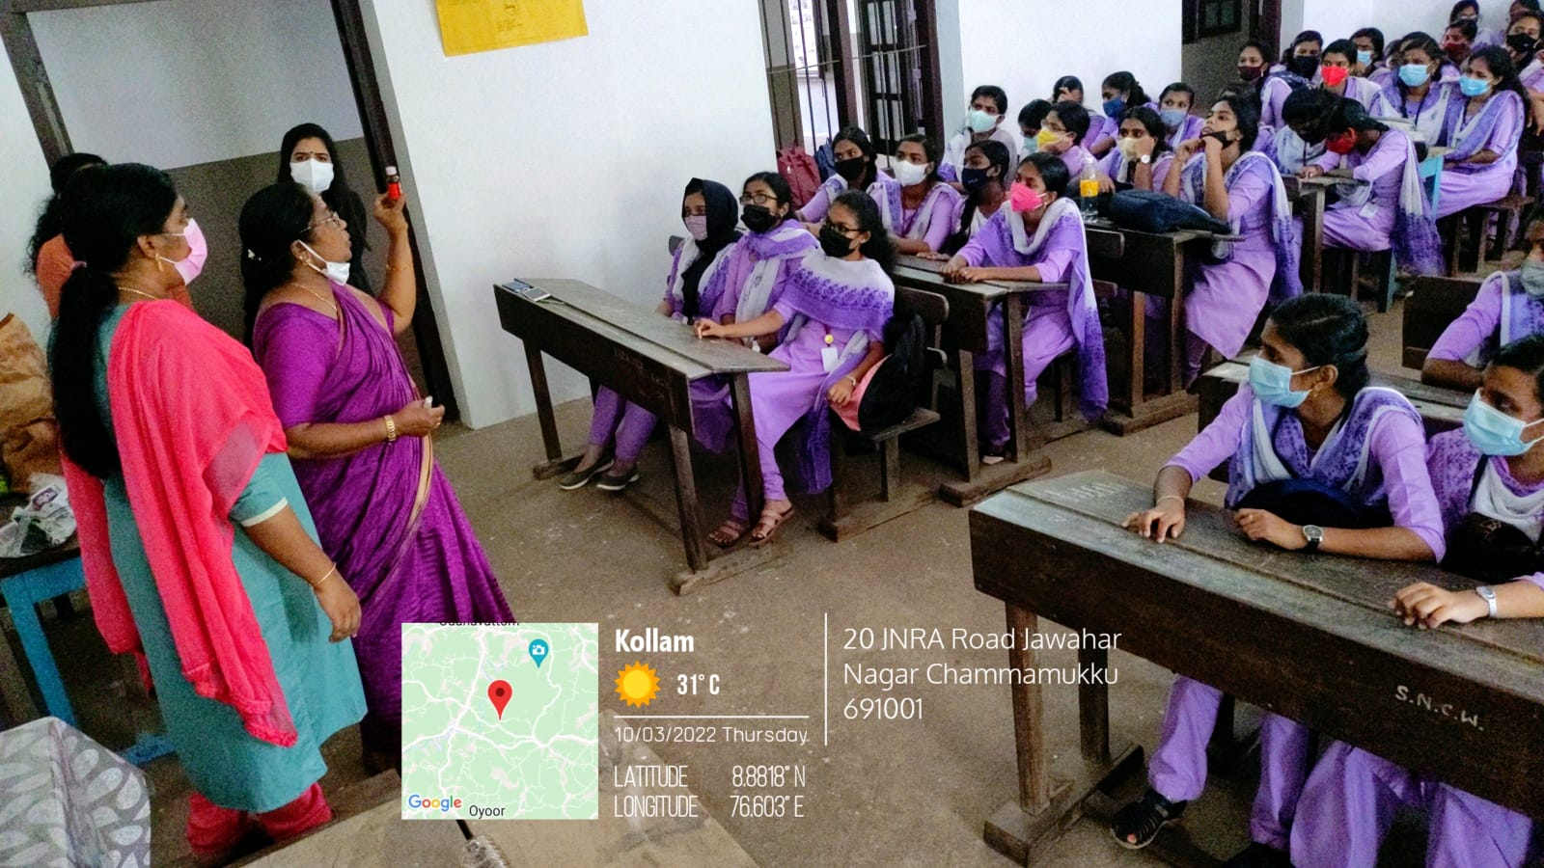

1. **Training on Floor Cleaning Lotion**

Entrepreneurship Development Club organised a skill development programme on making of floor cleaning lotion on 10/03/2022. All the club members and teachers were attended that session. Students are actively participated in lotion making process.

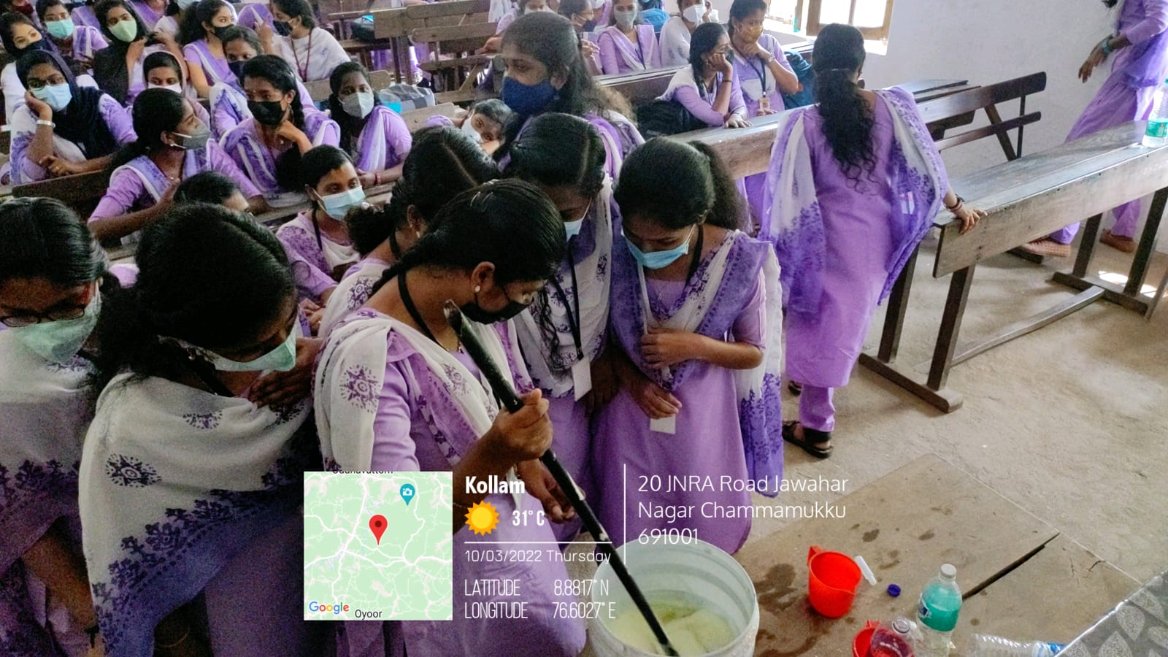

1. **Food Fest -Deliziosa 2k21**

Department of English has conducted a food fest on 14th December 2021 at the campus.

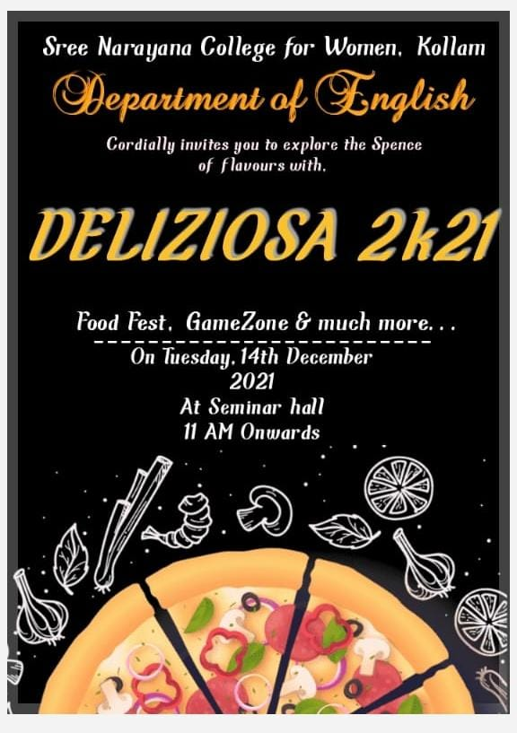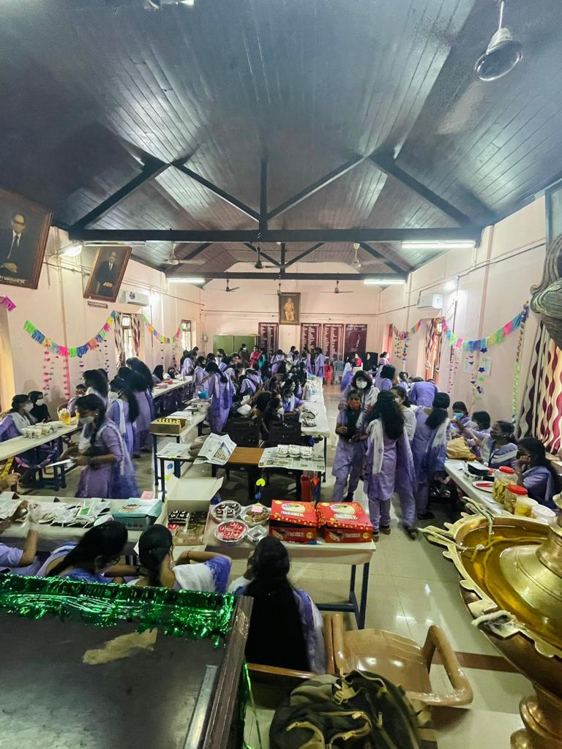

1. **Workshop on Fabric Painting Techniques**

The PG Department of Home Science in association with the Institution Innovation Council (Ministry of Education Initiative) organized a two days workshop on Fabric Painting Techniques on 11th and12th November 2021 in the T&C Lab from10.00am to 3.30pm. The resource person of the day was Ms.Rekha Anilkumar, Fevicryl Instructor. The workshop was conducted for the 5th semester BSc Home Science students. The students attended the workshop with great enthusiasm. The students had hands on experience on fabric painting techniques like Batik, Tie & Dye, Fabric painting, Block printing, 3D painting and Ikkat work. The instructor clearly explained the way of doing each work and the students keenly listened to it. The students really benefited from the workshop and all these fabric painting techniques they learned will definitely help them to earn income if they apply it in their future life.

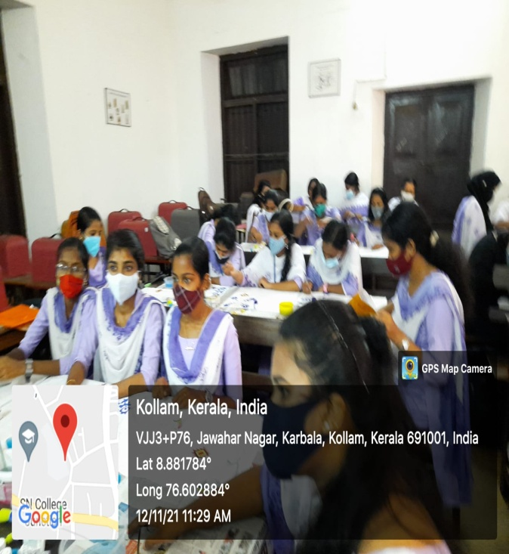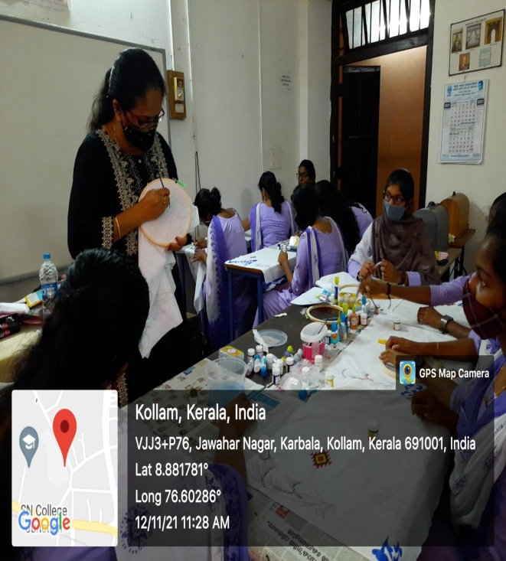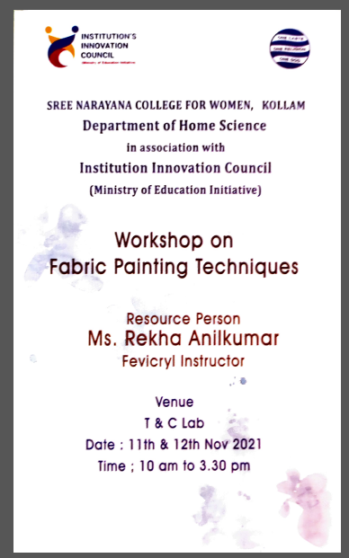

1. **Participation in Young Innovators Programme (YIP) 2021**

The YIP is a flagship program of the Kerala Development & Innovation Strategic Council (K-DISC) to promote a culture of innovation among the youth of Kerala. The state level inauguration was held at LBS Institute of Technology for women, Trivandrum and district level Inauguration was held at conference hall, Collectorate, Kollam. Sree Narayana College for Women has participated in the programme. 11 students from various departments attend the event. The program was held on 2nd December, Thursday from 2pm to 4.30 pm.

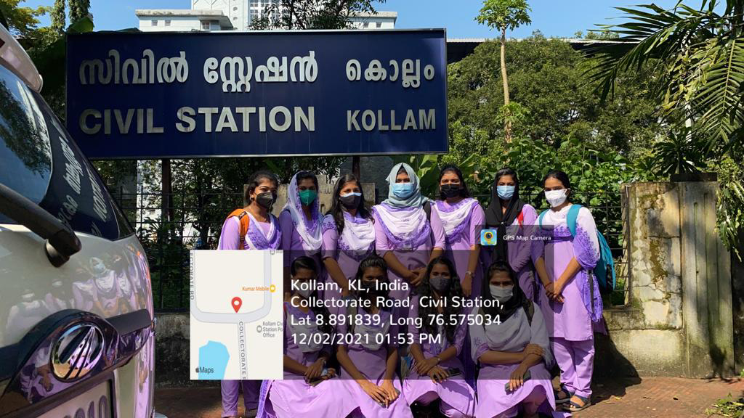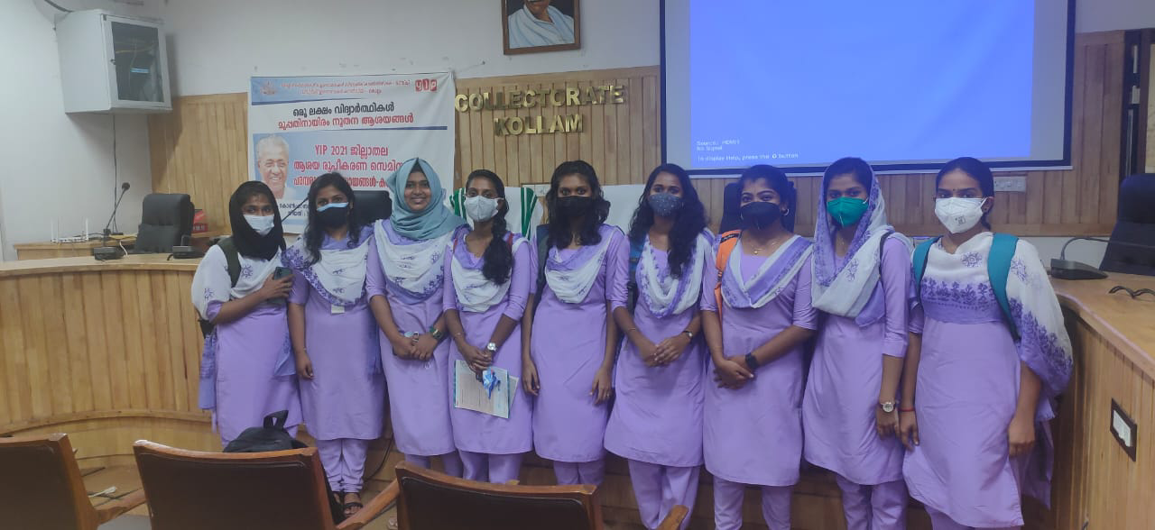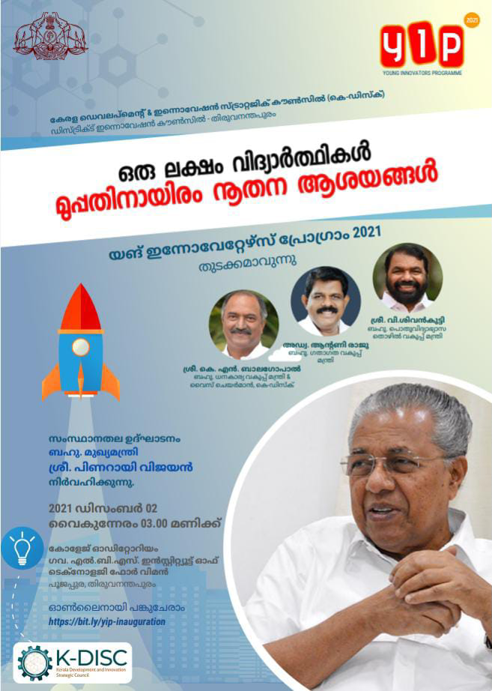

1. **Intellectual Property Rights (IPR) – An Overview**

As a part of Institutions Innovation Council and MoE’s Innovation cell (Government of India), Sree Narayana College for Women Kollam organized a webinar on Intellectual Property Rights (IPR) – An Overview on 30th November 2021 Tuesday 6.00 pm. The session was handled by Adv. Bilal A Nazeer, Research Officer, Inter University Centre for IPR Studies, CUSAT. The welcome address was delivered by Dr. Arunima S.R, IIC Convener and IPR activity coordinator Sree Narayana College for Women, Kollam. Resource person delivered an informative lecture on intellectual property rights and gave an overview on Copyrights, Trade Secrets, Trademarks and Patent. The session was wrapped up around 7:45 pm with an interactive session followed by the vote of thanks by Ms. Devi Ganga, Student member IIC, Sree Narayana College for Women, Kollam. Around 80 participants including faculty members, students and research scholars have attended the webinar. The webinar got a wide acceptance and positive feedback.

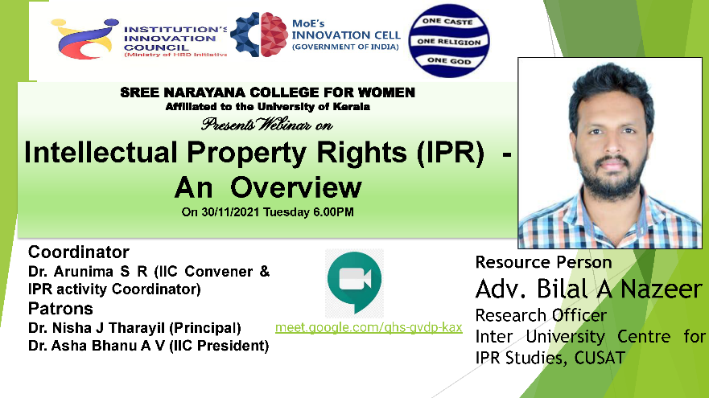

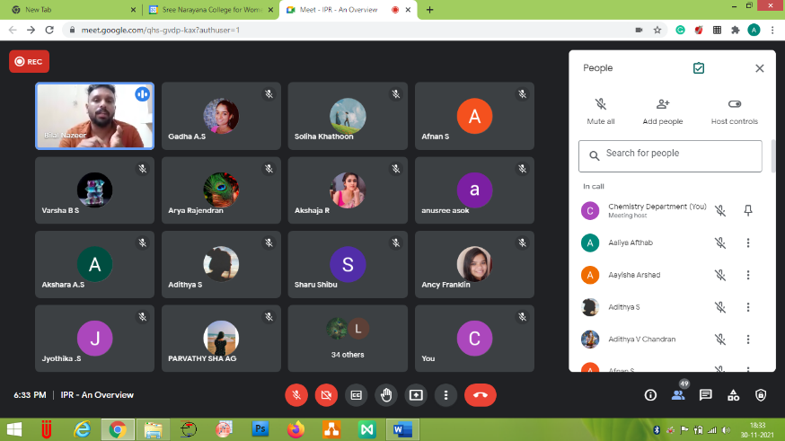

1. **My Story: Motivational Session by A Successful Entrepreneur**

A webinar was held on November 14, 2021, at 7 p.m. on behalf of the Institute Innovation Council. It was about a motivational speech by a successful entrepreneur. The program opened with a welcoming speech by Ms. Sajitha S (webinar coordinator, IIC member). Dr. K. Jajimol (founder of Jajis Innovation) was the main guest. She shared her experiences in the field of her business. In the early stages, she started a sewing unit in her home. But due to a lack of appropriate technical knowledge, she was unable to continue her sewing unit. She then acquired knowledge of fashion design, cosmetics, skincare and hair treatment, etc. Then she started a beauty salon in Kollam. During the initial stage of her new business, she had to face issues due to financial crunch, lack of cooperation among employees, etc. But after a few months, her turnover increased which boosted her confidence. More branches are opened in various districts in Kerala. Now Jajis Innovation has taken a unique position in this area. Dr. Jajimol also pointed out the importance of including vocational courses in the curriculum. This session was a motivating one. Most of the students were actively interacting with the lead guest. The webinar ended with a word of thanks from Afnan S (IIC member).

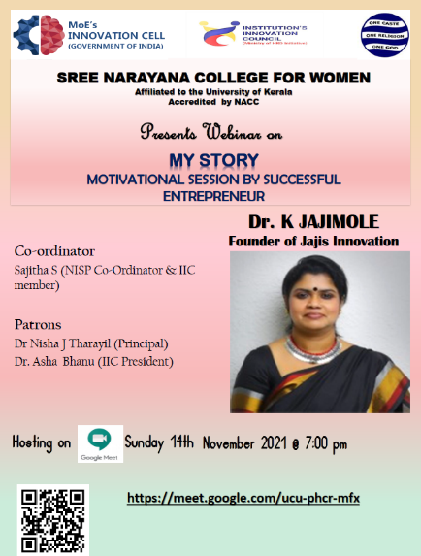 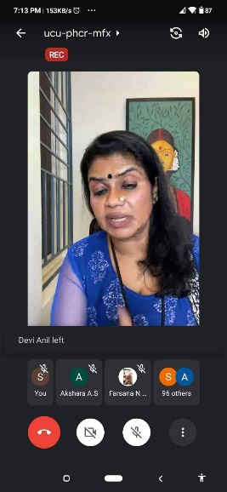

1. **Invited talk on Bridging the gap between theory and practicality- Application of Behavioural Economics theory to Actual Practice Areas**

An Invited talk on Bridging the gap between theory and practicality- Application of Behavioural Economics theory to Actual Practice Areas was delivered by Kavya MP, Research Scholar in Reinforcement Learing, University of Manchester and University of Stirling, UK on 27th July 2021. The programme was on online mode 50 students and 4 faculties attend the meeting.

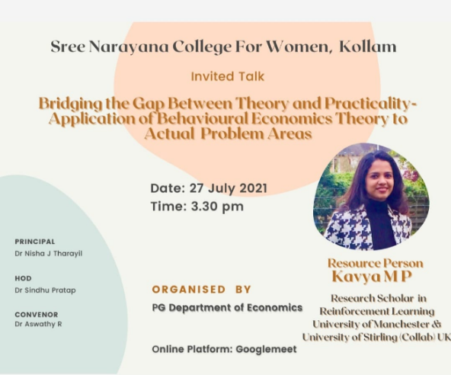 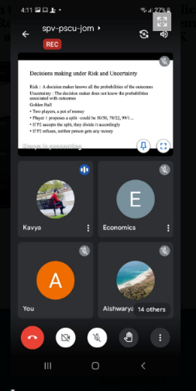

1. **Invited talk on Multiple Regression Analysis**

Invited talk on Multiple Regression Analysis by Dr. Reshmi C Panicker, Assistant Professor in Economics, University College, Thiruvananthapuram was held online on 24th July 2021. The programme was co-ordinated by Post Graduate department of Economics.

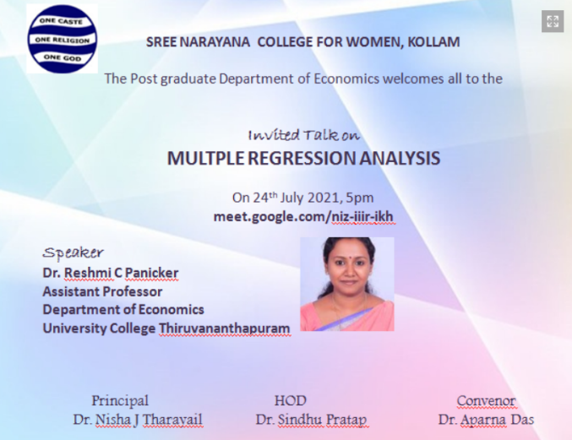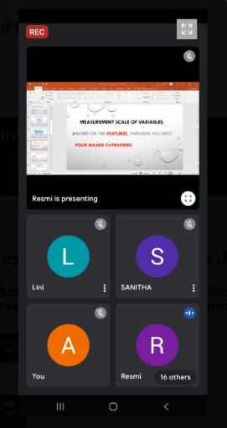

1. **International Webinar on Cyber Influence in Hindi Short-Stories**

An International Webinar on Cyber Influence in Hindi Short-Stories (Special Reference to 21st Century) was co-ordinated by department of Hindi. Resource Person was Lanskara Mudiyanselage Ridma Nishadinee Lanskara (Academic and Research Officer, NILET, University of Kelaniya on 25/06/2021.

