

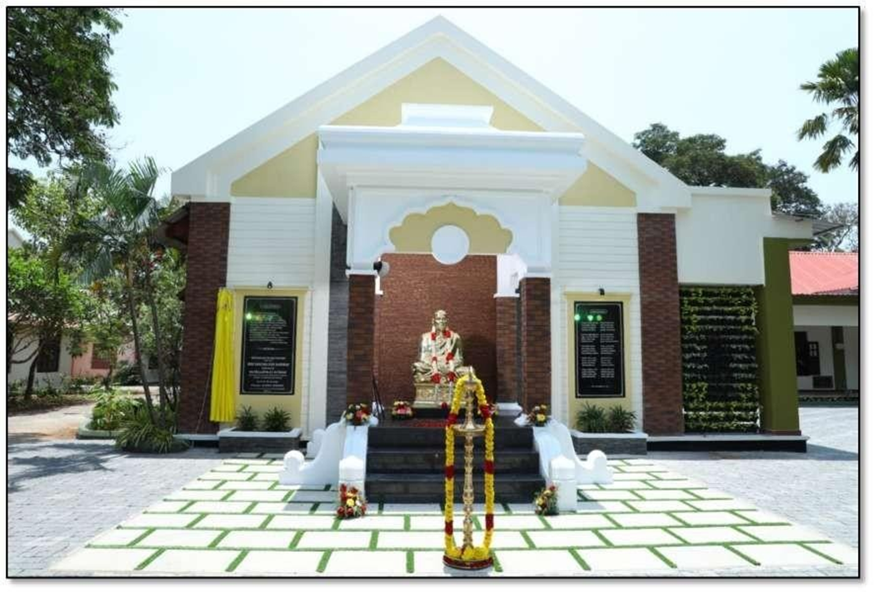

**7.1.1 GENDER EQUITY PROMOTION PROGRAMMES 2021-22**

# WEBINAR ON “DIET AND MIND HEALTH”

Maintaining a good healthy body and mind can be tricky. However, to see if you have a good and healthy body, you don’t have to take any complicated physiological and anatomical tests. The truth is that if you have the dedication and the discipline to maintain good health you can succeed in all walks of life. In order to create awareness among the students regarding the same, a webinar was conducted on the topic “DIET AND MIND HEALTH” in association with KSWDC, organised by the Women cell of Sree Narayana College for Women, Kollam on 11th November 2021. The webinar was organised with the objective of maintaining good physical and mental health among the students.

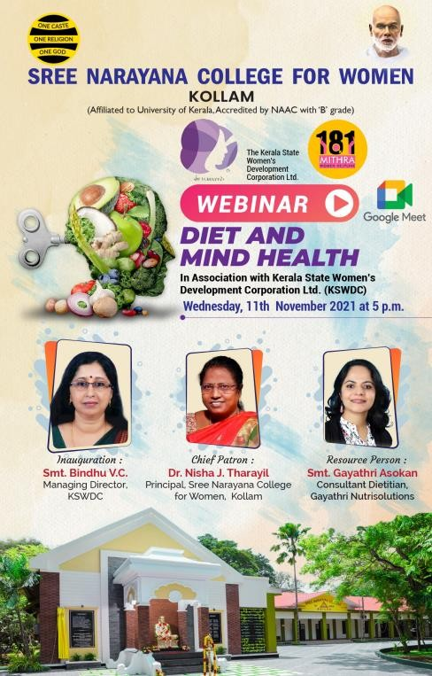

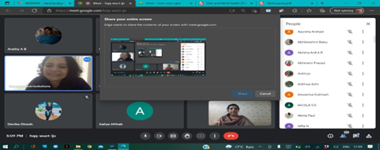

A Seminar on Out of the Box-An initiative to empower the women community

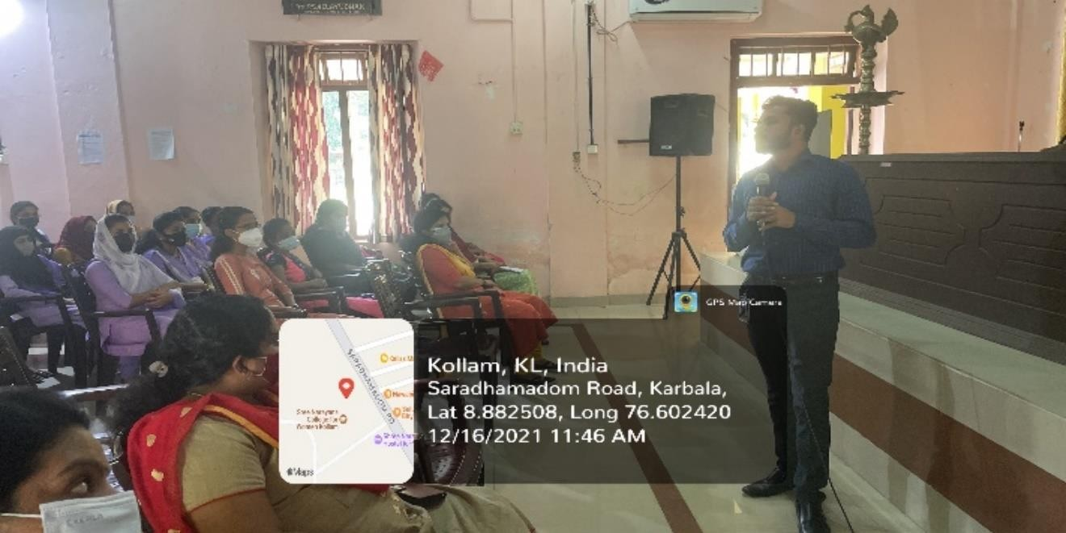Skill and knowledge are the driving forces of economic growth and social development for any country. Presently, the country faces a demand – supply mismatch, as the economy needs more ‘skilled’ workforce than that is available. In the higher education sphere, knowledge and skills are required for diverse forms of employment in the sector of education, health care manufacturing and other services. Taking note of the requirement for skill development among students, Women Cell of Sree Narayana College for Women, Kollam have organised a Seminar on “Out of the Box-An initiative to empower the women community” on 16th December 2021. A total of 100 students from various departments have been benefited by this seminar.

A Webinar on ‘Amending the outmoded Dowry Prohibition Act 1961- Inevitable or not?’.

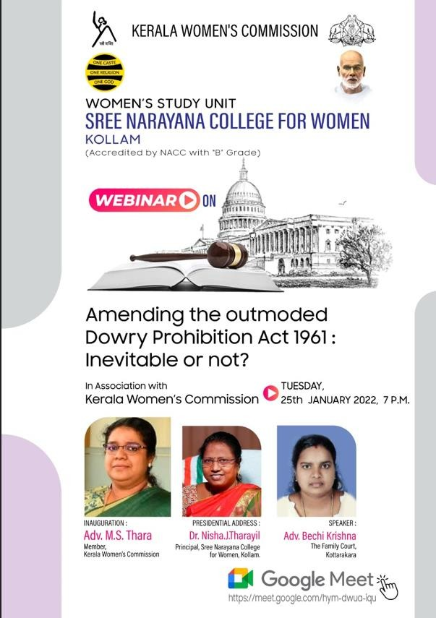

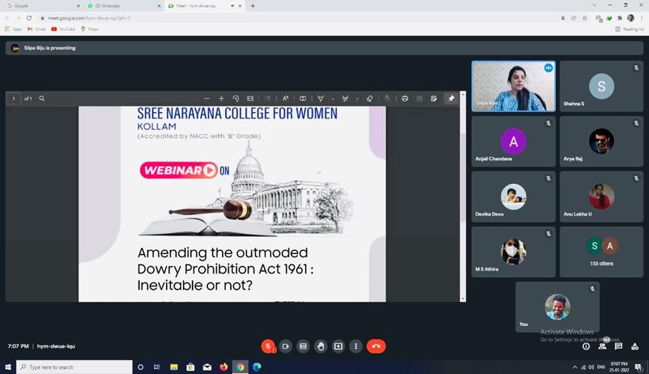Across India there is evidence of the increasing dimensions of dowry as an essential basis of match making, and in Kerala too there is a sharp visibility of curse of dowry demand and dowry death. It is ironic that in India dowry was originally designed to safeguard the woman and it was the provision of “Streedhan”. Presided over by the Principal Dr.Nisha.J.Tharayil, the webinar was attended by honourable chief guest Adv.M.S.Thara, member of Kerala Women’s Commission and Adv. Bechi Krishna, Lawyer of Kottarakara Family court and over 180 students from various departments. webinar was coordinated by Dr. Silpa Sasankan, Assistant Professor of Department of Commerce and Co-ordinator of Women’ s Study Unit.

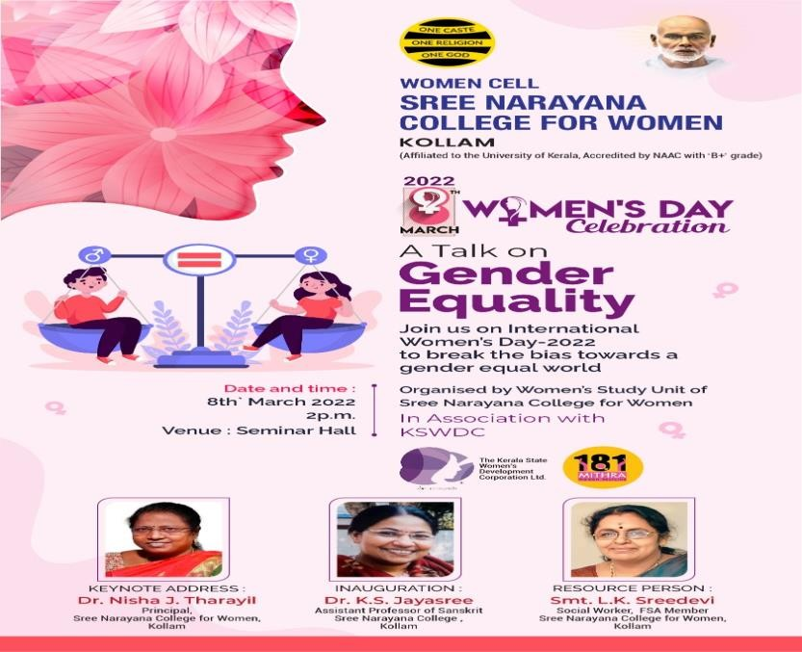A Talk on ‘Gender equality’

On the occasion of international Women’s Day on March 8th 2022, Sree Narayana College for Women, Kollam has organised a talk on ‘Gender equality’. The programme was organised by Women Cell of the college in association with KSWDC.

The Chief guest and the resource person was Dr. K.S. Jayasree , Founder and General Secretary of Streechetana which is functioning for empowering women. She inaugurated the ceremony and spoke about the importance of understanding ourselves, living with dignity and most importantly being a helping hand to those who are in need. She encouraged the students to have an assertive quality to say “no” in the needed situations. She also talked about the values which we should adhere to as value defines one’s personality

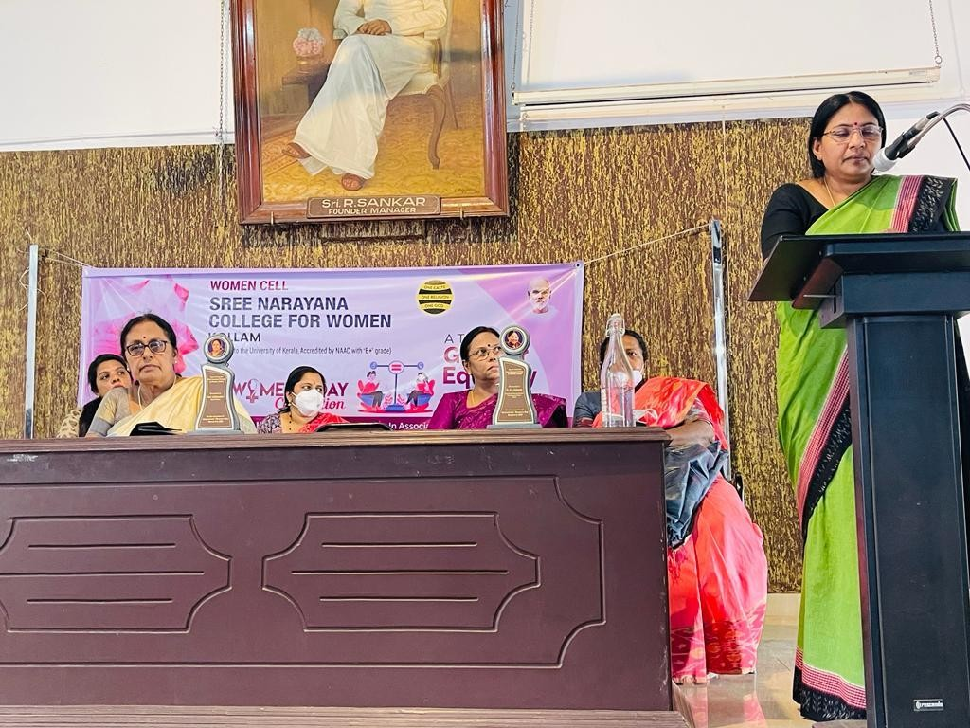

A Training Programme on MS Word And Excel

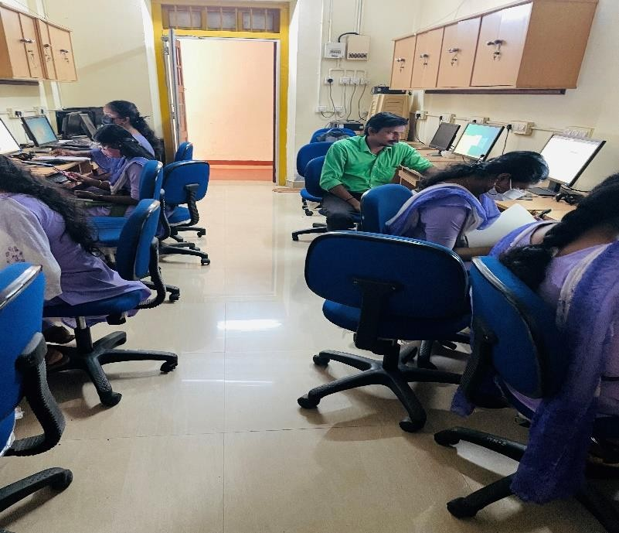Women Cell in association with KSWDC organised a training programme on Ms Word and Excel to selected number of students of all U.G. programmes on 18/03/2022 and 19/03/2022 at our IT Mission Lab. A total 150 students attended the training session. The workshop was really beneficial for the students as they were enriched with the basics of Ms Word and Excel and they also realised the importance of both in the job market.

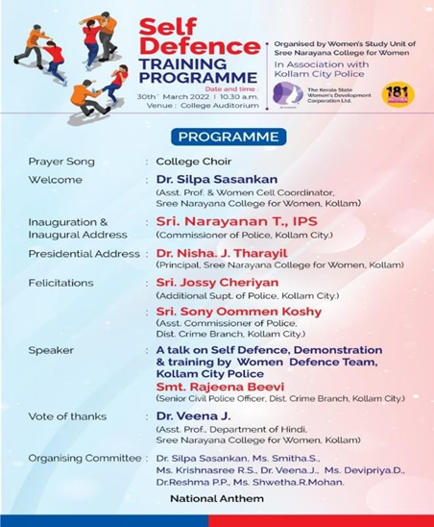

Women Study Unit (WSU) of Sree Narayana College for Women, Kollam has organised a self defence programme on 30th March 2022. Sri. Narayanan T, IPS, City police commissioner. Kollam, inaugurated the auspicious programme. He talked about the various initiatives taken by Kerala police empower the women like Pink Police, Janamythjri project, Nirbhayam app, district conflict resolution centre and so on. He also handed over prizes to our students for showing their excellence in various areas.

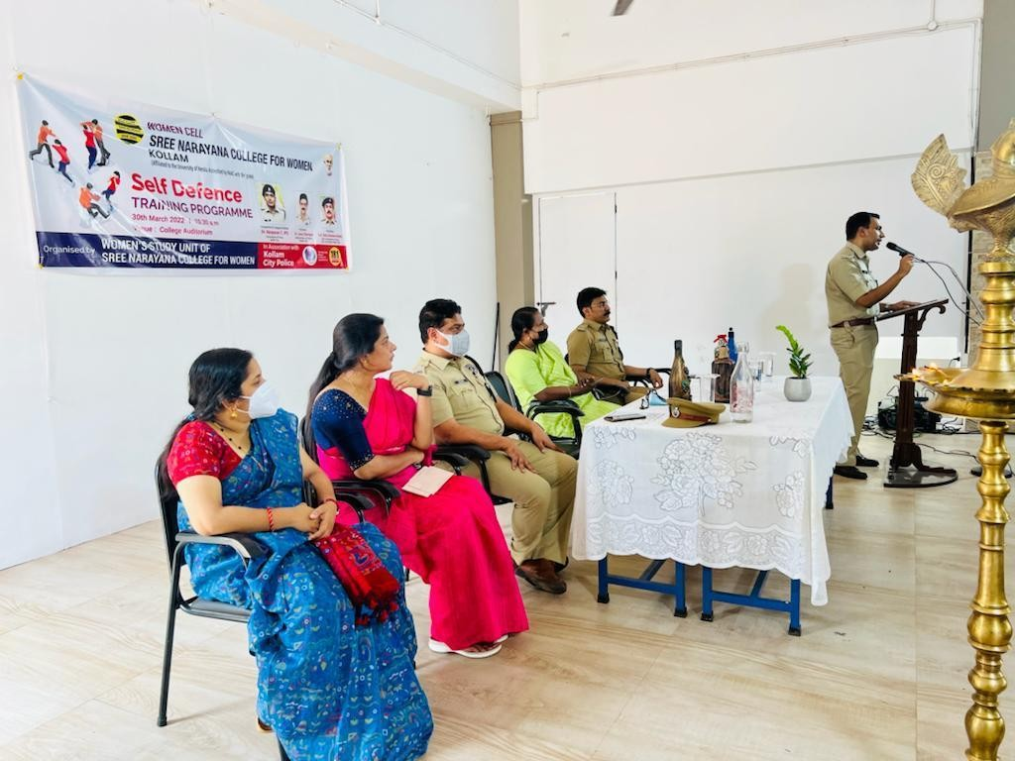Sri. Jossy Cherian, Additional Supt.of police, Kollam and Sri. Sony Omen Koshy, Assistant Commissioner of Police made a mind-blowing speech and congratulated Women Cell for organising such a worthy programme.

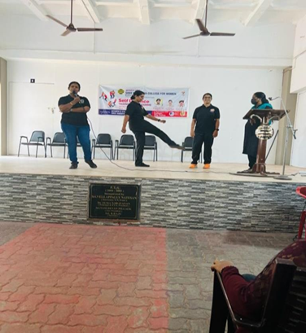

A Seminar on History of Human Rights Movements in India

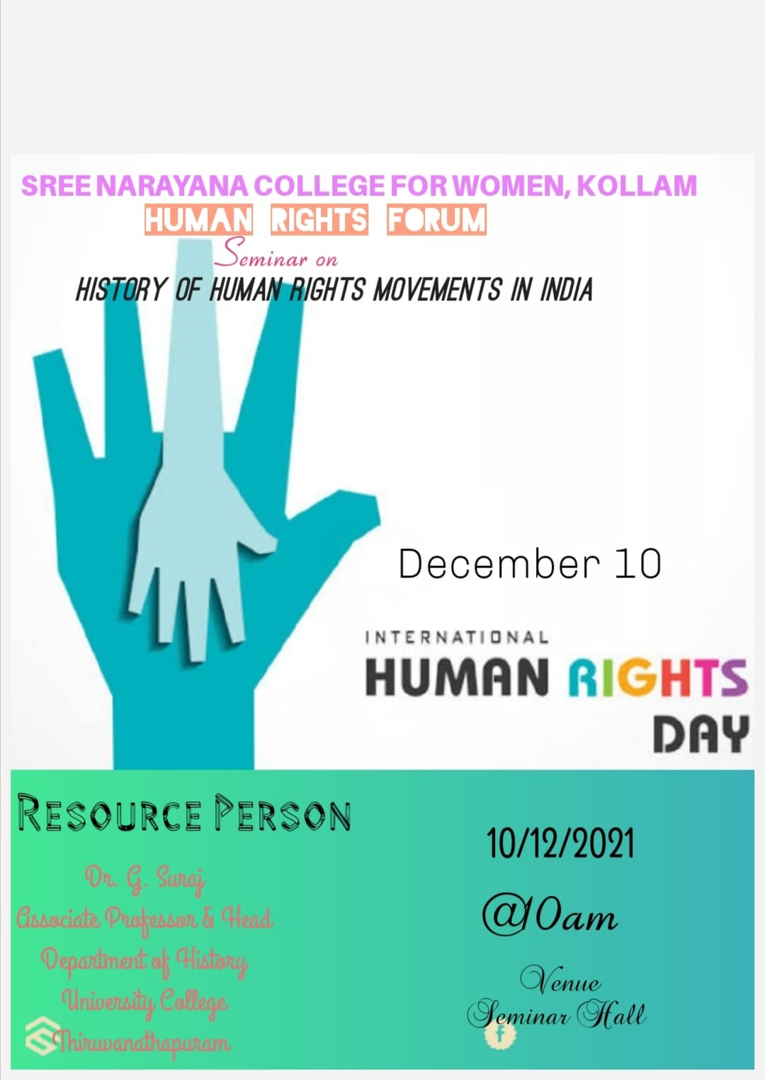

Human Rights Forum of Sree Narayana College for Women, Kollam conducted a seminar on the topic ‘History of Human Rights Movements in India ‘on 10/12/2021. The resource person of the seminar was Dr.G.Suraj ,Associate Professor &Head ,Department of History, University College, Thiruvananthapuram .He gave an elaborate and entertaining lecture on the topic History of Human Rights Movements in India.

Motivational session by a successful entrepreneur

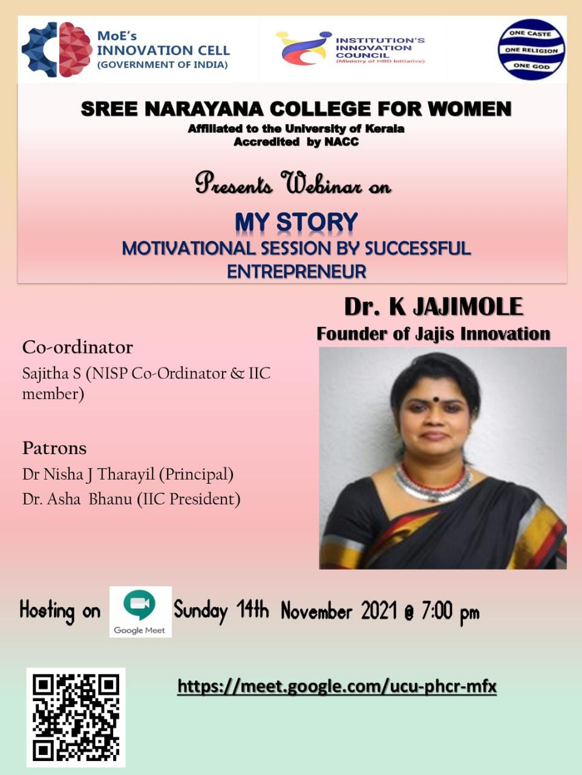

A webinar was held on November 14, 2021, at 7 p.m. on behalf of the IIC. It was about a motivational speech by a successful entrepreneur. The program opened with a welcoming speech by Ms. Sajitha S (webinar coordinator, IIC member). Dr. K. Jajimol (founder of Jajis Innovation) was the main guest. She shared her experiences in the field of her business. 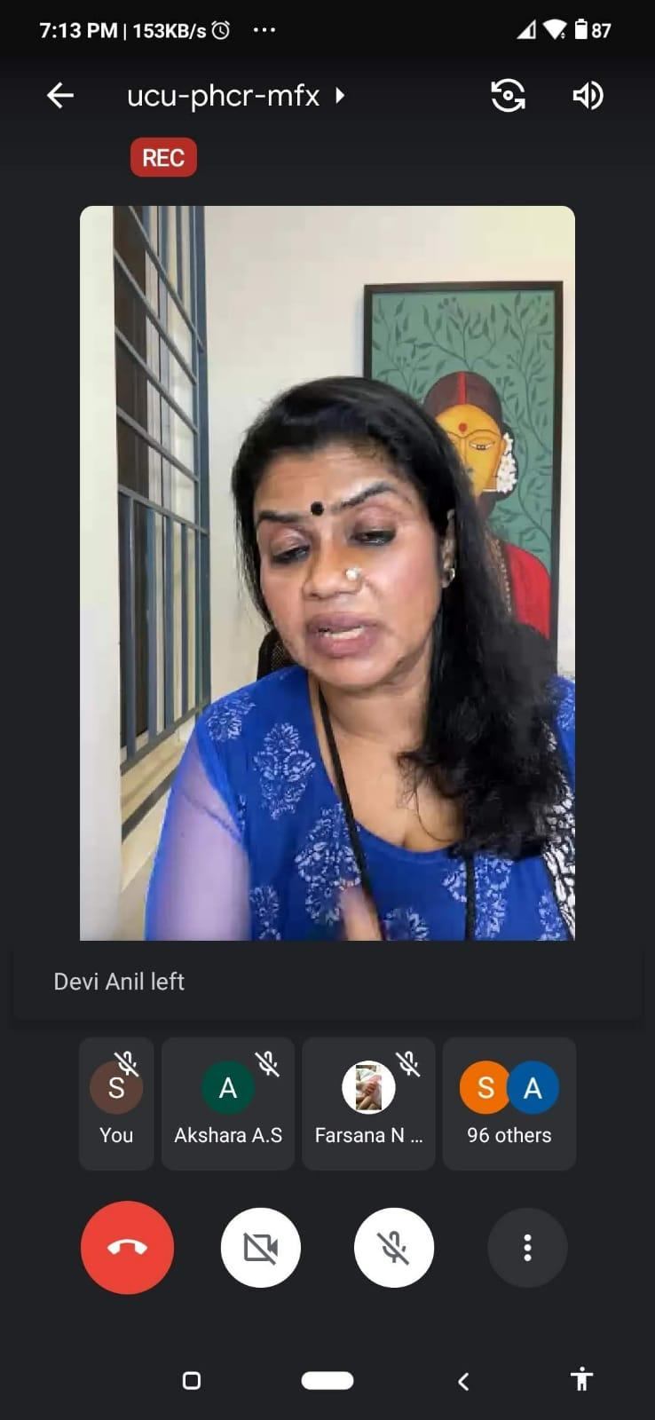

Pledge to fight gender-based violence against women and children

Students and Teachers took Pledge in our Campus at 3 pm on 13.12.2021 to fight gender based violence against Women and girls***.***

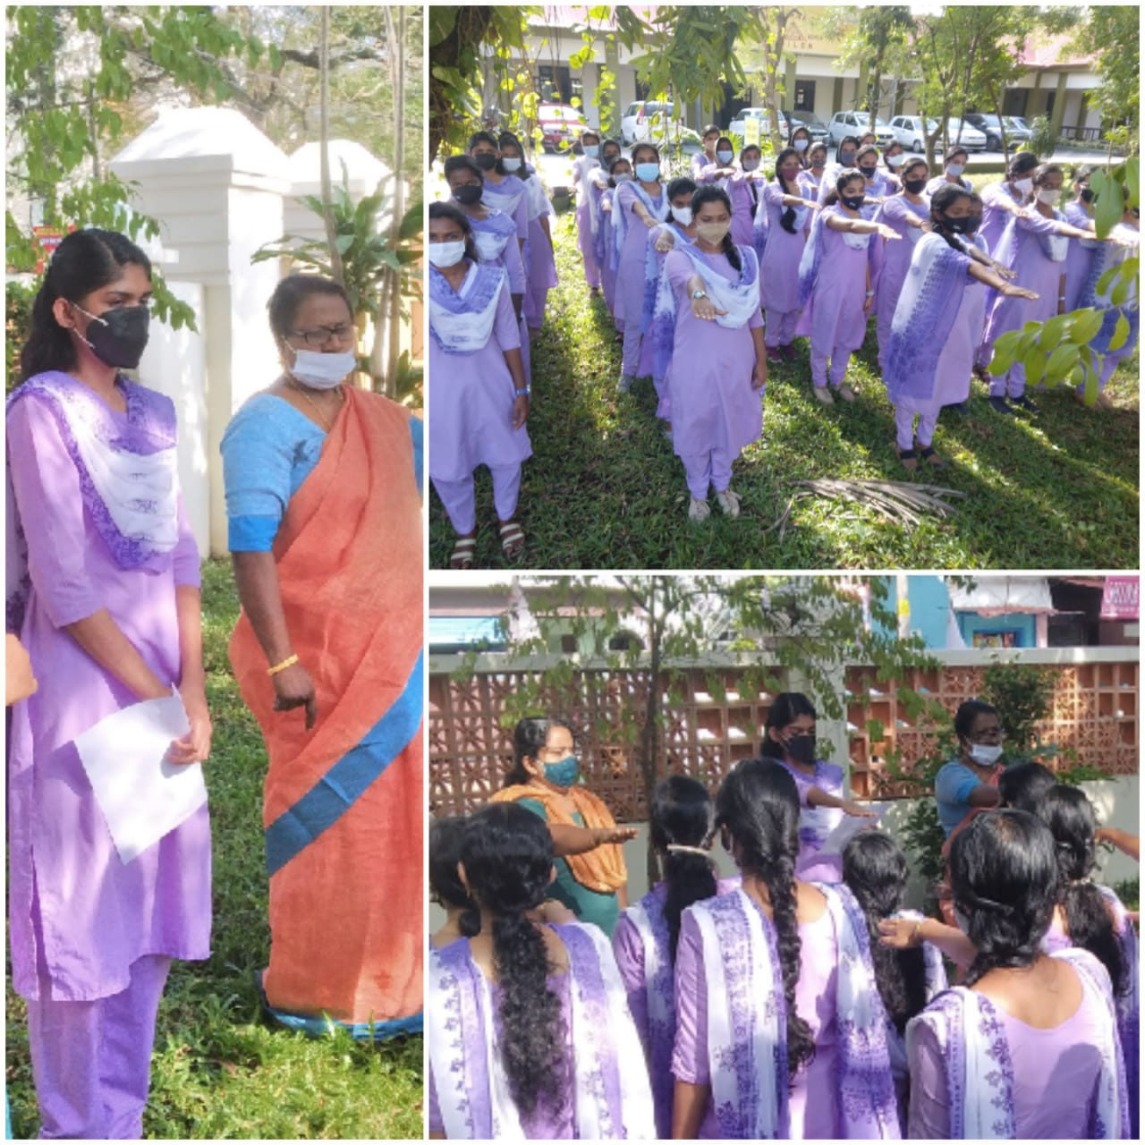

Two-day Workshop on Fabric Painting Techniques

The PG Department of Home Science in association with the Institution Innovation Council (Ministry of Education Initiative) organized a two days workshop on Fabric Painting Techniques on 11th and12th November 2021 in the T&C Lab from 10.00am to 3.30pm. The resource person of the day was Ms.Rekha Anilkumar, Fevicryl Instructor***.***

