**Report of the activities of Entrepreneurship Development Club**

**Sree Narayana College for Women Kollam 2020-2021**

Government of Kerala asper the direction from Kerala Institute for Entrepreneurship Development have set up ED club in educational institution with the objective to inculcate entrepreneurial culture among the younger generation and to change the mindset on negative attitude prevailing about the industry in the state. This year the ED club has 50 members .A committee of faculty members was formed with Smt. Sajitha S(Assistant professor of Commerce) as convenor ,Dr. Berny B Raj(Assistant Professor of Commerce), Dr. Nithya U S(Assistant Professor of Commerce) and Smt. Smitha S(Assistant Professor of Physics) Smt. Aswathy S M(Assistant Professor of English) as faculty members for the proper functioning of this club.

(1)The activities of entrepreneurship development club of this year started with a skill development programme. It was an online programme conducted on 27/08/2020. Today’s session was about how to make an attractive and useful carpet from old and useless dress material. Club convenor smt. Sajitha S delivered welcome speech. Our most beloved principal Dr. Nisha J Tharayil presided over the meeting. In her presidential address she pointed out the importance of craft work and self employment schemes during this Covid period. Smt. Saraswathy Radhakrishan(JSS approved trainer) demonstrated how to make a carpet . She cleared the doubt raised by students and their family members. It was a nice experience to all the participants. All the students were interested to attend this class and some of them are able to make beautiful carpets. All the faculty members were attend the meeting . The meeting was ended with the vote of thanks by Dr. Nithya U S.

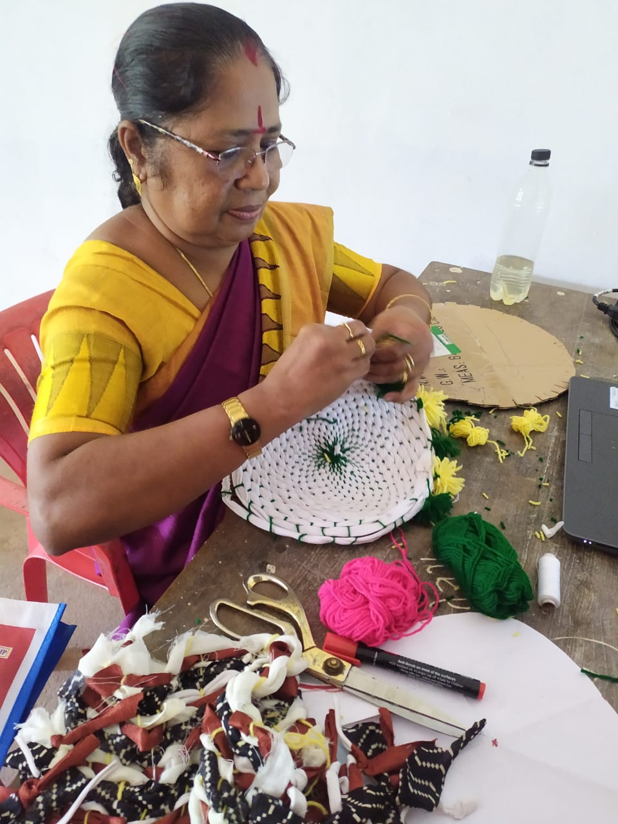

(2) On 15/12/2020 Entrepreneurship development club organised a webinar on passionpreneur. The programme was started with welcome speech by Sajitha S (club co-ordinator). Mr. Shaharudeen A(JCI certified Trainer) lead the class. He pointed out the importance of business in the present era. He also give a brief description about the upcoming business oppertunities in our state. All the participants were actively participated in this webinar. Mr. Dinesh Rajappan (Manager DIC)also participated in that webinar. He give a clear picture about the various financial schemes available for starting self employment schemes. All the club members were participated in that webinar. The function was ended with the vote of thanks by Dr.Berny B Raj.

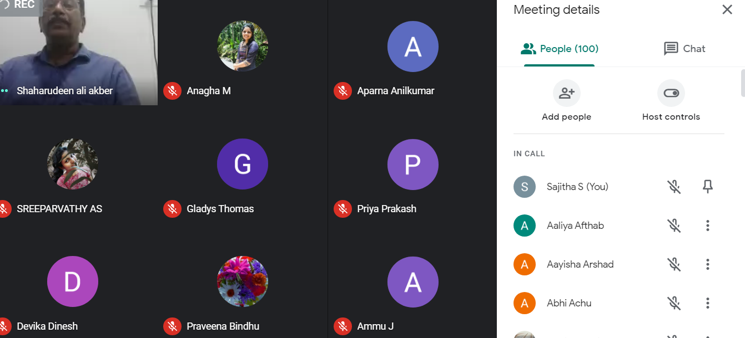

3.On 16/01/2021 Entrepreneurship Development club organised an online skill development programme. It was about how to make liquid dishwash at home. Smt. Sajitha S (club convenor)welcomed all the participants to the programme. Smt. Saraswathy Radhakrishnan was the resource person. 85 students were actively participated in this class. In addition to that their parents got an opportunity to attend this session. All the participants got an idea about how to make dishwash gel at low rate . It was a new experience to the participants .

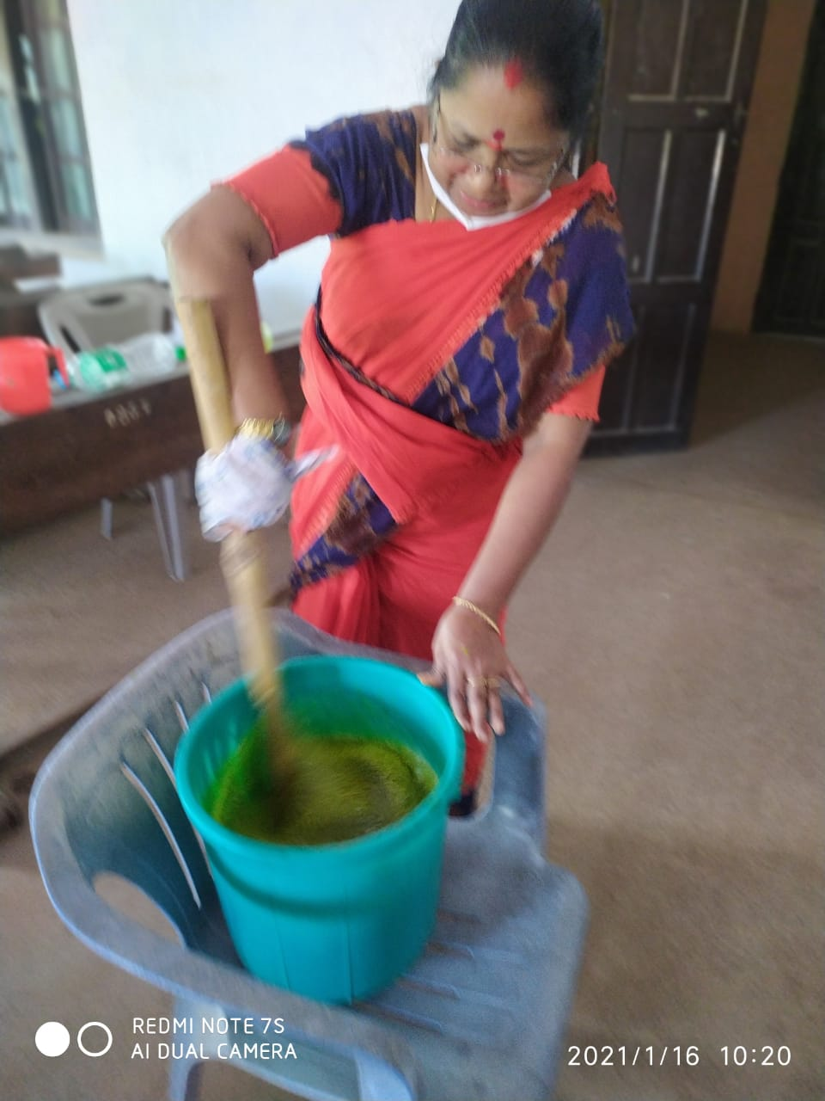

**Report of the activities of Entrepreneurship Development Club**

**Sree Narayana College for Women Kollam 2021-2022**

My Story

Motivational session by a successful entrepreneur

1.A webinar was held on November 14, 2021, at 7 p.m. on behalf of the IIC. It was about a motivational speech by a successful entrepreneur. The program opened with a welcoming speech by Ms. Sajitha S (webinar coordinator, IIC member). Dr. K. Jajimol (founder of Jajis Innovation) was the main guest. She shared her experiences in the field of her business. In the early stages, she started a sewing unit in her home. But due to a lack of appropriate technical knowledge, she was unable to continue her sewing unit. She then acquired knowledge of fashion design, cosmetics, skincare and hair treatment, etc. Then she started a beauty salon in Kollam. During the initial stage of her new business, she had to face issues due to financial crunch, lack of cooperation among employees, etc. But after a few months, her turnover increased which boosted her confidence. More branches are opened in various districts in Kerala. Now Jajis Innovation has taken a unique position in this area. Dr. Jajimol also pointed out the importance of including vocational courses in the curriculum. This session was a motivating one. Most of the students were actively interacting with the lead guest. The webinar ended with a word of thanks from Afnan S (IIC member).

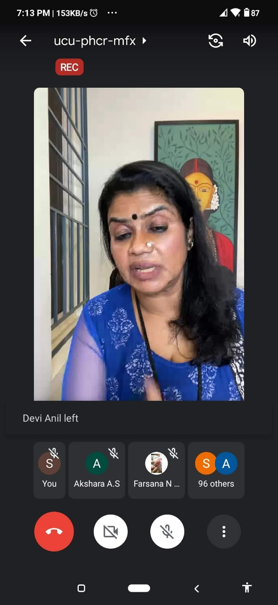

On 10/03/2022 a skill development programme relating to the making of room spray was organised by Entrepreneurship Development Club. Smt.Saraswathy Radhakrishnan was the resource person . 75 students were participated in that class.

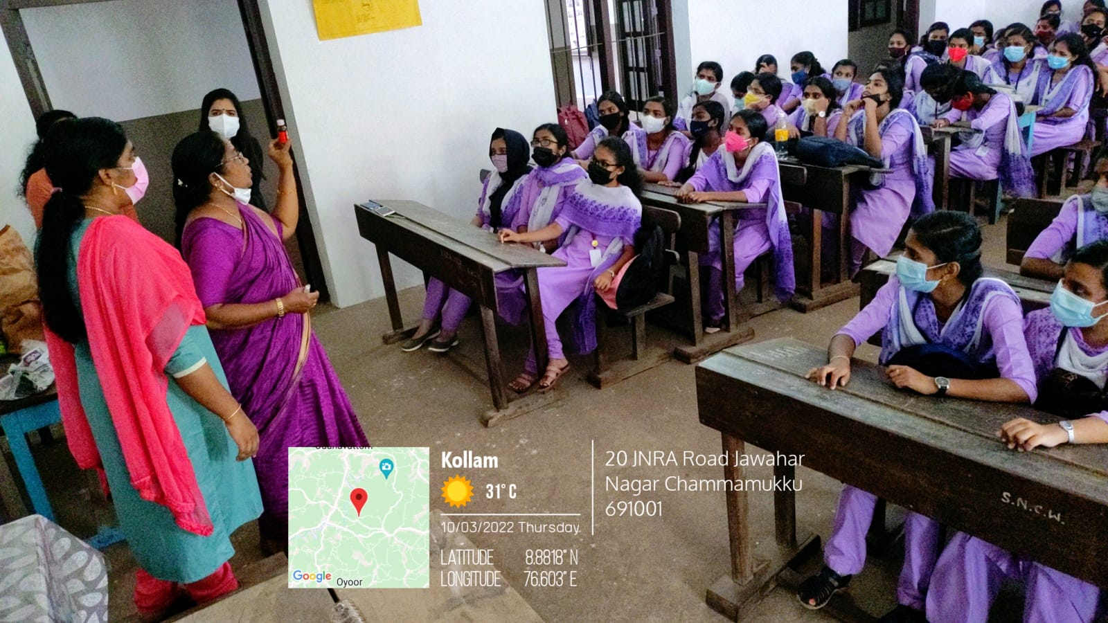

Entrepreneurship Development Club organised another skill development programme on making of floor cleaning lotion on 10/03/2022. All the club members and teachers were attended that session. Students are actively participated in lotion making process.

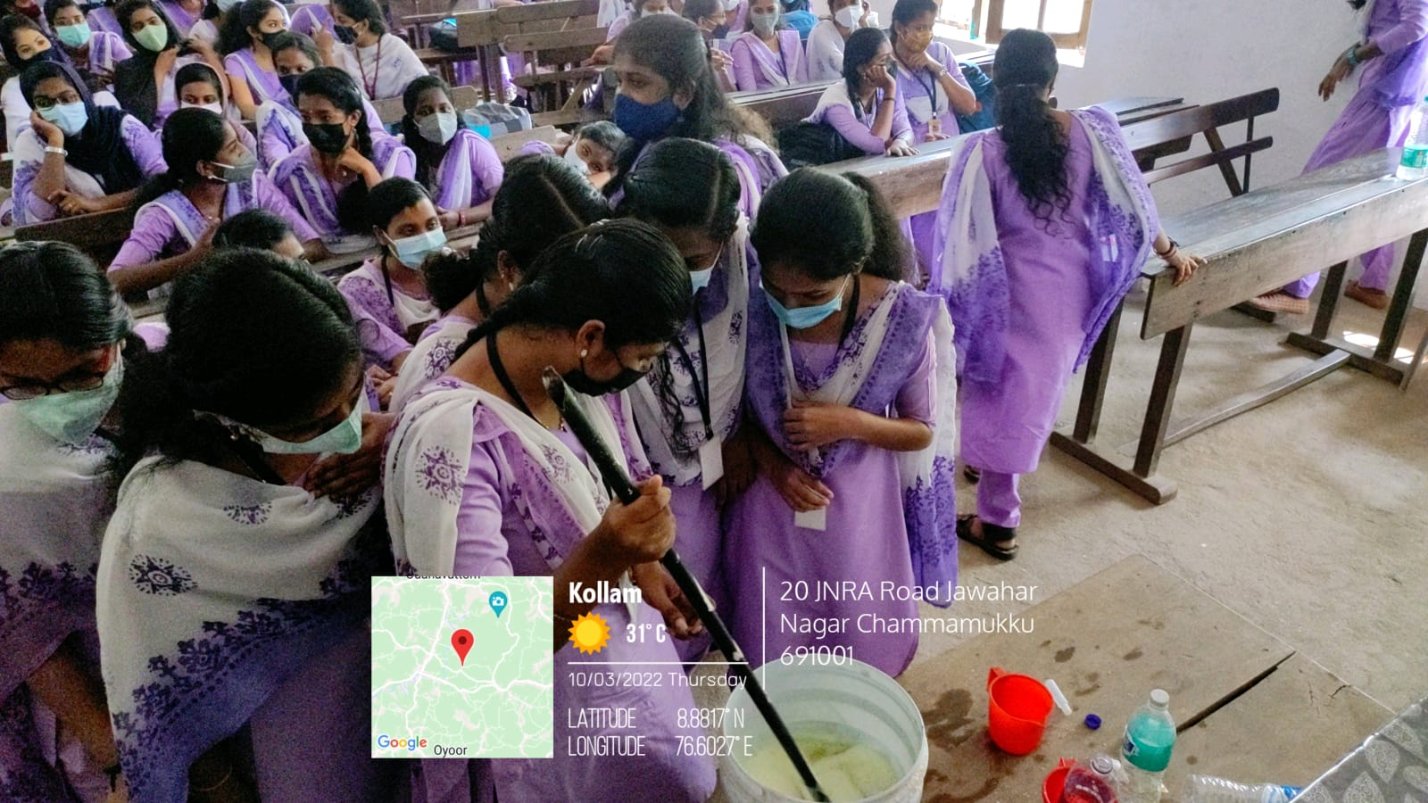

On 15/03/2022 as part of “**Earn While You Learn project**”, Entrepreneurship Development Club and Department of Commerce jointly organised an exhibition cum sale named **Thrift Exhibito** at College auditorium. It was a golden opportunity to our students for exhibiting their talents in making of craft items, food items and cleaning products like dishwash gel, bathing soap, room freshner, cleaning lotion, detergent etc.

